IOCReaper

Manudeep Maddipatla – mmaddipa@umd.edu
121417350 – mmaddipa

Table of Contents

Table of Contents 2

Application Description:- 3

Use Cases:- 4

Overview :- 5

Use Case 1: Upload and Extract IOCs from a Document 5

Use Case 2: Export Extracted IOCs 6

Use Case 3: Search for a Specific IOC in an Uploaded Document 7

Use Case 4: Tag IOCs by Type 9

References:- 11

Table of Figures

Figure 1. 10,000 feet overview of the use cases of IOCReaper. 5

Figure 2. Use case diagram to upload and extract IOCs from a document. 6

Figure 3. Use case diagram to export extracted IOCs. 8

Figure 4. Use case diagram for searching for a specific IOC in the uploaded document. 9

Figure 5. Use Case Diagram for tagging IOCs by Type 11

Application Description:-

The advent of wider adoption of threat hunting led detection strategy has led to a gradual increase by organisations in placing greater importance on crafting detection mechanisms that utilise threat intelligence about, and around cyber threat attacks, colloquially referred to as threat feeds. These threat feeds could contain a variety of information about the attacks, which are referred to as indicators of compromise or attack. Collected and collated from various paid and unpaid sources, these indicators are used either as a source for early indication of the presence of a threat actor or as evidence of a successful intrusion within the organisational environment [1] .
However, with the weak adoption of existing threat intelligence sharing mechanisms and the limited availability of technical applications that could assist an organisation in processing and normalising the threat intel information into an actionable data set feeds into the limited analysis hours an organisation has . Thus pointing to an opportunity for design and development of an application which would aid analysts to accomplish the above tasks at ease and scale [2] [3].
These are the problem statements that IOCReaper is meant to solve, ultimately aiding analysts to properly capture, transform and actionize threat-related indicators received from various sources and in different data formats in a quick and flexible manner, all the while providing a potential for extensibility for additional functionality as and when needed [4].
Though extensibility is a value-add feature, the primary need for this applications has been centred around 4 core actions highlighted as 4 separate use cases below.

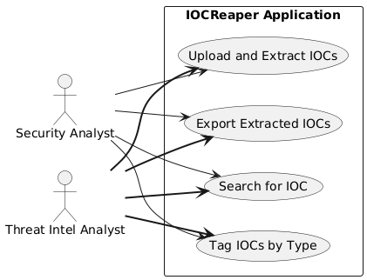
Figure 1. 10,000 feet overview of the use cases of IOCReaper.

Use Cases:-

Overview :-
The below sections describe 4 main use cases for the web application going into details about the expected users , a breakdown of actions taken to successfully execute the use case and finally several potential edge error scenarios .
These use cases were ideated and designed using the help of AI specifically Perplexity Ai, the use was limited to drafting the rough sketches of the use cases .[5]

Use Case 1: Upload and Extract IOCs from a Document

- Actor:

  - Security Analysts
  - Threat Intel Analysts

- Goal: Extract IOCs (IP addresses, domains, URLs, hashes) from text copied out of a document or website.

- Success Scenario:

- Analysts receive threat intelligence from various sources (ISACs, Paid Sources, Open-Source feeds, etc) in the threat intelligence provider`s preferred format.
- Analyst opens the application in a browser.
- Analyst copies and pastes text from the threat report, PDF, Word file, or website into the provided text box.
- Analyst clicks the “Extract IOCs” button or executes the action.
- System scans the pasted text for the presence of the IOCs.
- System displays a structured list of the IOCs, organised by type (e.g., IP addresses, domains, URLs, hashes).

- Error Cases:

- Text Box Empty due to lack of input text provided by the user, the remediation action in such a case is to notify the user either with a pop-up or notification indicating the lack of text in the input field for any action by the application.
- The threat intelligence report or site does not contain any text string that matches the known IOC expression format, the remediation action in such a scenario is to notify the user with the information that “No IOCs were identified”.

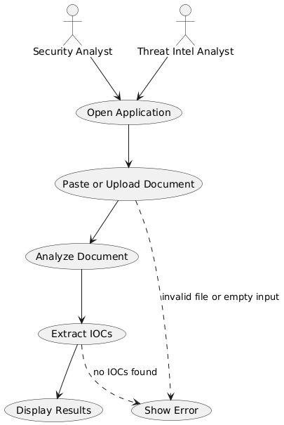
Figure 2. Use case diagram to upload and extract IOCs from a document.

Use Case 2: Export Extracted IOCs

- Actor:

  - Security Analysts
  - Threat Intel Analysts

- Goal:

  - One of the expected functionalities of this application is the ability to export the extracted IOCs by converting them into standard data formats for use in external tools.

- Success Scenario:

- The analysts review the extracted IOCs.
- Upon identifying the IOCs within the text input, an analyst would then export these indicators by selecting the export option.
- A list of preferred export format options is provided to the analyst.
- The IOCs are then exported successfully in the preferred format.
- These files are then integrated or reused by the analysts in their required investigative or analysis procedures.

- Error Cases:

- The export generation might fail due to various errors. Then the analyst is informed about the failure of the action and is suggested to retry the exporting action.
- If an unsupported format is requested to the application , the export action fails with an error message notification about the lack of the requested format, and the list of available options is presented to the analyst.
- The export action might fail due to network or bandwidth issues; the analyst is then alerted about this failure and requested to retry the export action.
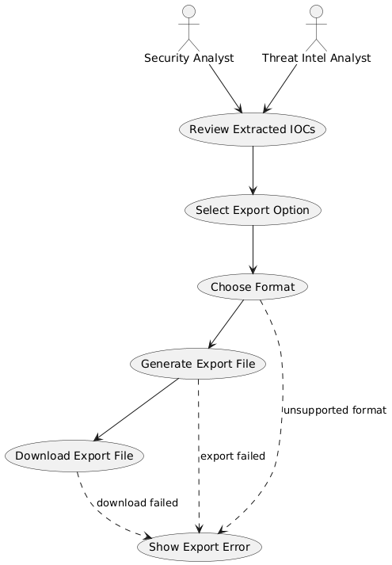
Figure 3. Use case diagram to export extracted IOCs.

Use Case 3: Search for a Specific IOC in an Uploaded Document

- Actor:

  - Security Analysts
  - Threat Intel Analysts

- Goal:

  - To provide an option for the analyst to quickly verify the presence of a particular IOC with the text and find its location.

- Success Scenario:

  - The analyst selects and indicator, for which they would like to validate the presence of.
  - The search interface is opened by the analyst.
  - The IOC value is entered into the search field.
  - The system validates the input format to confirm if it is part of an allowed list of indicator types to search for.
  - Once validated, the search action is initiated on the uploaded and processed IOCs.
  - If a match is identified, the locations are highlighted within the data.
  - If no match is identified, the same is also notified to the analyst.
  - Upon a successful match, the analyst reviews and investigates the highlighted results for response or documentation.

- Error Cases:

  - If no IOC is identified, the system should display a no match found message.
  - The input format is either invalid or not from the approved list of patterns; if identified, a prompt indicates the analyst correct their input.
  - If the search operation fails, then the system informs the analysts and requests them to try the search operation again.

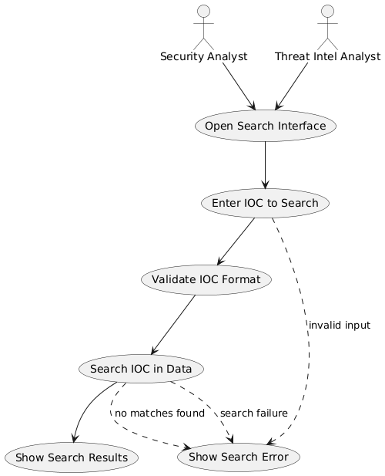
Figure 4. Use case diagram for searching for a specific IOC in the uploaded document.

Use Case 4: Tag IOCs by Type

- Actor:

  - Security Analysts
  - Threat Intel Analysts

- Goal:

  - Recategorize the extracted IOCs into their predefined types (IPs, domains, hashes, URLs) for easier navigation and analysis.

- Success Scenario:

  - Once the IOCs are extracted by the application, they are then analysed individually by the application.
  - Pattern recognition is applied to automatically assign IOC types.
  - Then IOCs of different types are organised into separately identified sections, clubbing the indicators of a similar type into one location.
  - Analysts can then navigate to each category to review the sorted IOCs.
  - Analysts then can tag or review additional IOCs with custom details as necessary.

- Error Case:

  - The provided text might not have any indicators; in such a scenario, the application prompts the user that it has not detected any known indicator format and suggests them to repeat the action.
  - The application might categorise indicator of one type into another type due to matching pattern recognition conditions; the analysts can manually adjust the tags to categorise the indicator into their desired indicator type.

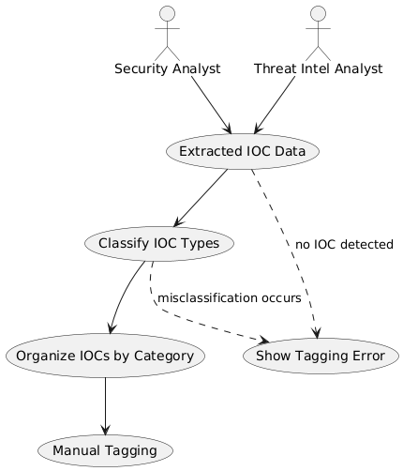
Figure 5. Use Case Diagram for tagging IOCs by Type

References:-

[1] “SANS_D-Basilio-On-The-Hunt-The-Retroactive-Proactive-Hunt-CTI-Indicators.pdf on Egnyte,” Egnyte. Accessed: Sept. 14, 2025. [Online]. Available: https://sansorg.egnyte.com/dl/MIPJmSEiW0
[2] “Cyber threat intelligence sharing: Survey and research directions,” Computers & Security, vol. 87, p. 101589, Nov. 2019, doi: 10.1016/j.cose.2019.101589.
[3] “NIST Special Publication 800-150.” [Online]. Available: https://nvlpubs.nist.gov/nistpubs/specialpublications/nist.sp.800-150.pdf
[4] L. Rocha, “Extract and use Indicators of Compromise from Security Reports,” Count Upon Security. Accessed: Sept. 14, 2025. [Online]. Available: https://countuponsecurity.com/2017/01/12/extract-and-use-indicators-of-compromise-from-security-reports/
[5] Perplexity AI. Perplexity. [Online]. Available: https://www.perplexity.ai/

